PROJECT DOCUMENTATION

1. Introduction

Project Title : Educational Organisation Using ServiceNow

Team Details
Team Leader: Mulinti Hima Sree
Team Member: Bukaya Eswar Naik

2. Project Overview

Purpose
The purpose of this project is to design and implement a ServiceNow-based application for managing educational organization processes such as admissions and student academic progress. The system reduces manual effort, improves data accuracy, and provides a centralized platform for administrative operations.

Features
- Custom tables for Salesforce, Admission, and Student Progress
- Automated number generation using Number Maintenance
- Dynamic forms with structured layouts
- Auto-population of fields using Client Scripts
- Automatic calculation of total marks, percentage, and result
- Process Flow Formatter for tracking admission status

3. Architecture
- Frontend: Built using ServiceNow Form Design and Layout tools for responsive forms.
- Backend: Logic implemented via Client Scripts (onChange and onLoad).
- Database: Three primary tables – Salesforce, Admission, and Student Progress – linked using reference relationships.

4. Setup Instructions

Prerequisites
• ServiceNow Personal Developer Instance
• Internet Browser
• Basic knowledge of ServiceNow Administration

Installation / Setup
1. Create a ServiceNow Personal Developer Instance
2. Log in with administrator credentials
3. Create an Update Set for the project
4. Configure custom tables and fields
5. Design forms and layouts
6. Implement process flows and client scripts

5. Folder Structure

├── 📂 Data Model (Tables)

│ ├── 📄 Salesforce [u_salesforce]

│ ├── 📄 Admission [u_admission]

│ └── 📄 Student Progress [u_student_progress]

├── 📂 Forms & UI

│ ├── 📋 Form Design (Salesforce)

│ ├── 📋 Form Design (Admission)

│ ├── 📋 Form Design (Student Progress)

│ └── 📈 Process Flow Formatter (Admission)

├── 📂 Client Side Logic (Client Scripts)

│ ├── 📜 Auto-Generate Admission Number (onLoad)

│ ├── 📜 Auto-Populate Student Data (onChange)

│ ├── 📜 Calculate Marks & Results (onChange)

│ ├── 📜 Address Auto-fill based on PIN (onChange)

│ └── 📜 Alert on Submission (onSubmit)

└── 📂 Security & Access

├── 📜 Disable Fields After Finalization (onChange)

└── 📜 Role-Based Access Controls(ACLs)

6. Running the Application
The application runs on the ServiceNow cloud platform. Users can access it by logging into the ServiceNow instance URL and navigating to the configured application modules.

7. API Documentation
The project uses ServiceNow Table APIs for internal data handling. These APIs support secure CRUD operations within the platform.

8. Authentication
Authentication and authorization are handled through ServiceNow role-based access control. Users log in with credentials, and access is assigned based on roles.

9. User Interface
• Custom forms for Salesforce, Admission, and Student Progress
• Process Flow Formatter for admission tracking
• Auto-calculated and read-only fields
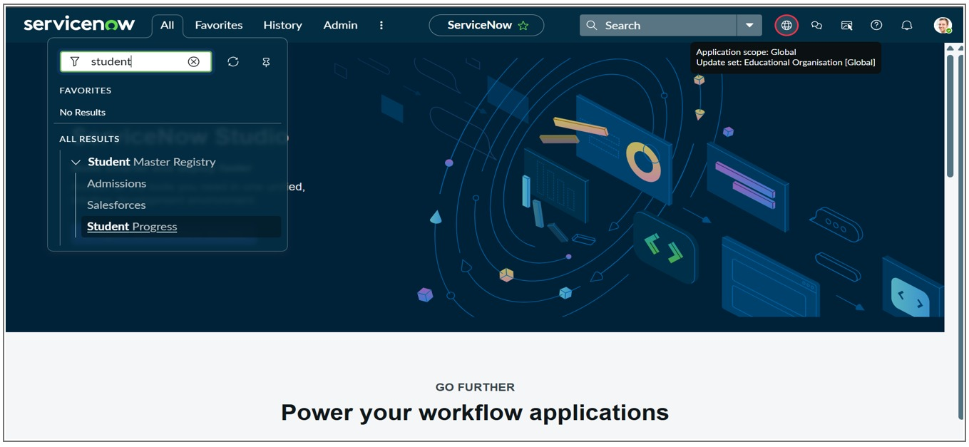
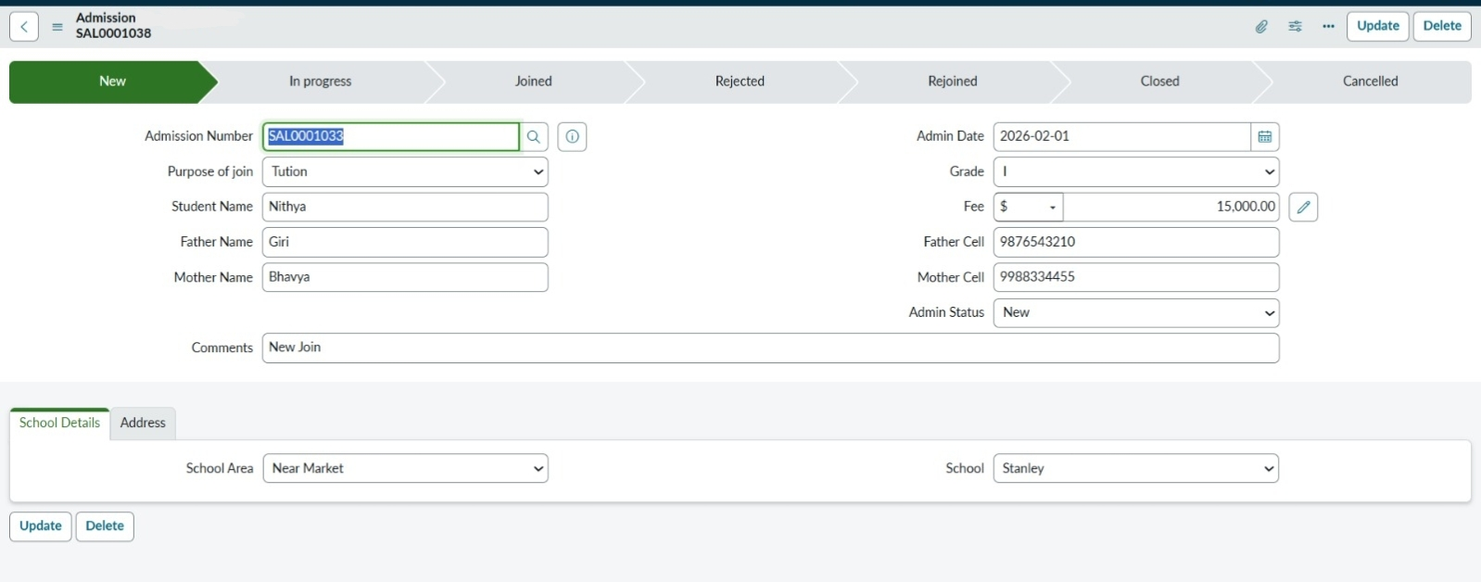
Fig 1: Application Navigator showing custom modules and table structure.

Fig 2: Admission form highlighting the Process Flow Formatter.

10. Testing
- Testing ensured accurate auto-population of fields
- Correct calculation of marks and results
- Proper disabling of calculated fields
- Smooth functioning of process flow stages

11. Screenshots or Demo

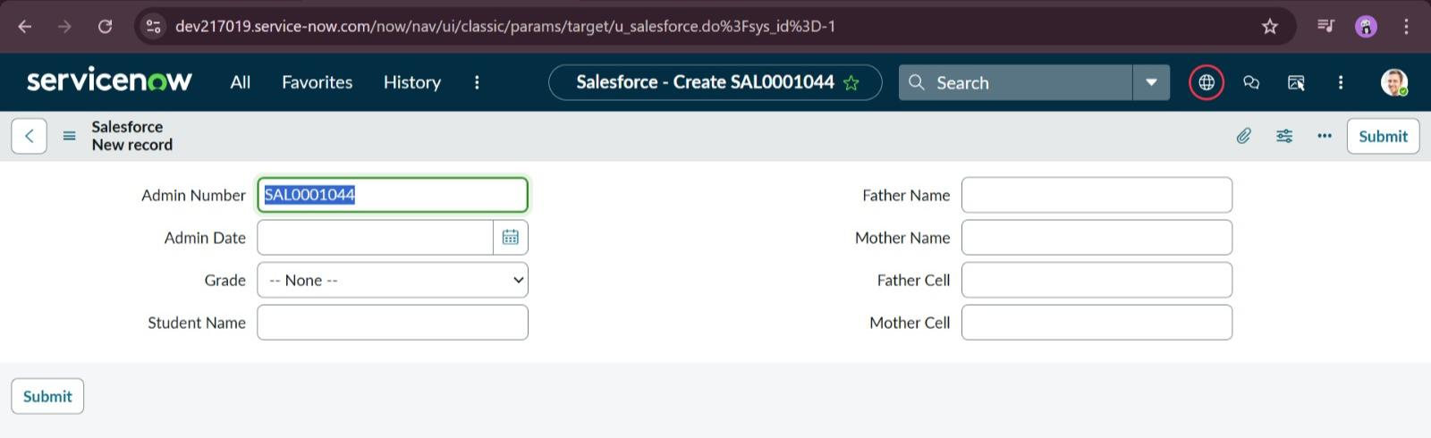
Fig 3: Salesforce master form for student record creation.
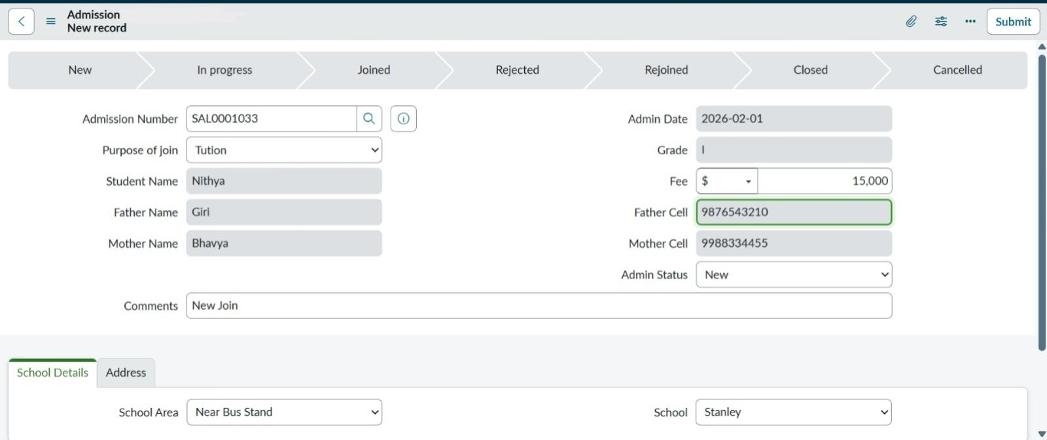
Fig 4: Live Admission form with auto-populated data.
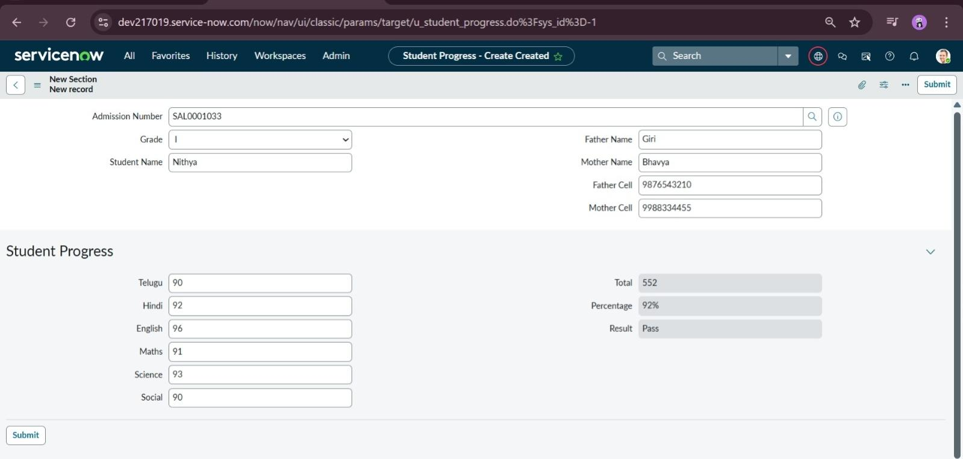
Fig 5: Student Progress record with automated result calculations.
Demo Link:
https://drive.google.com/file/d/14ZHvtxgxkd6MDguu4SVrPP91UKxo9Vjn/view?usp=drivesdk

12. Known Issues
• Advanced UI customization is limited
• Requires stable internet connectivity
• Basic ServiceNow knowledge is required

13. Future Enhancements
• Integration with notification services
• Dashboard and reporting features
• Role-based portals for students and faculty
• Additional academic management modules

